AWS DEPLOYMENT

RDS

The existing RDS service was used where the database was built as provided in the folder 4.Backend\Data_Base.

ERS.

Two repositories were created for the backend services:

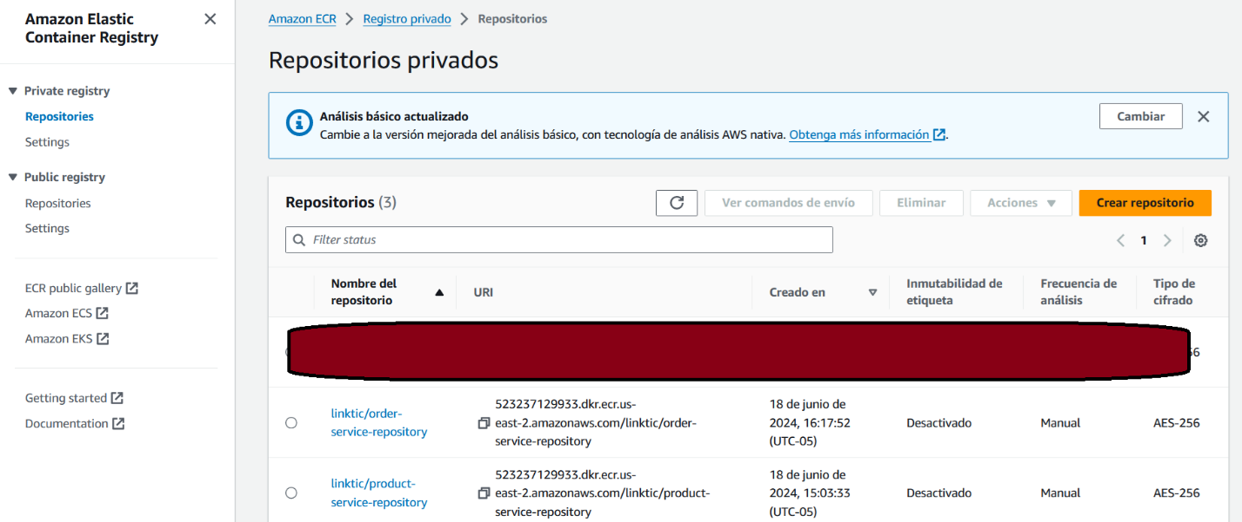

With these repositories created, the source code is synchronized, and the ECS service can perform the deployment and execution tasks for each of the services.

ECS.

Two clusters were created for the backend services in the AMAZON Elastic Container Service (ECS).

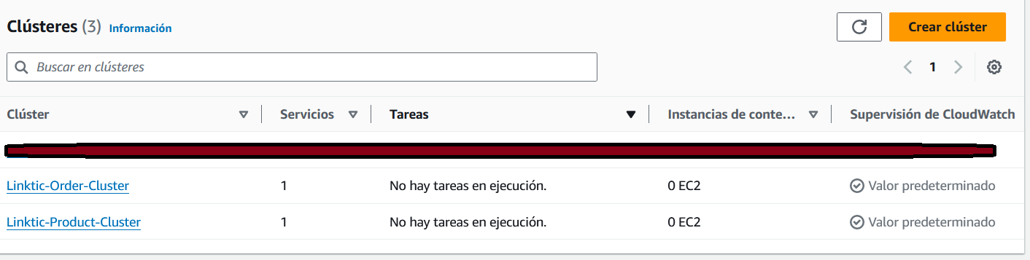

Two tasks were created for each backend.

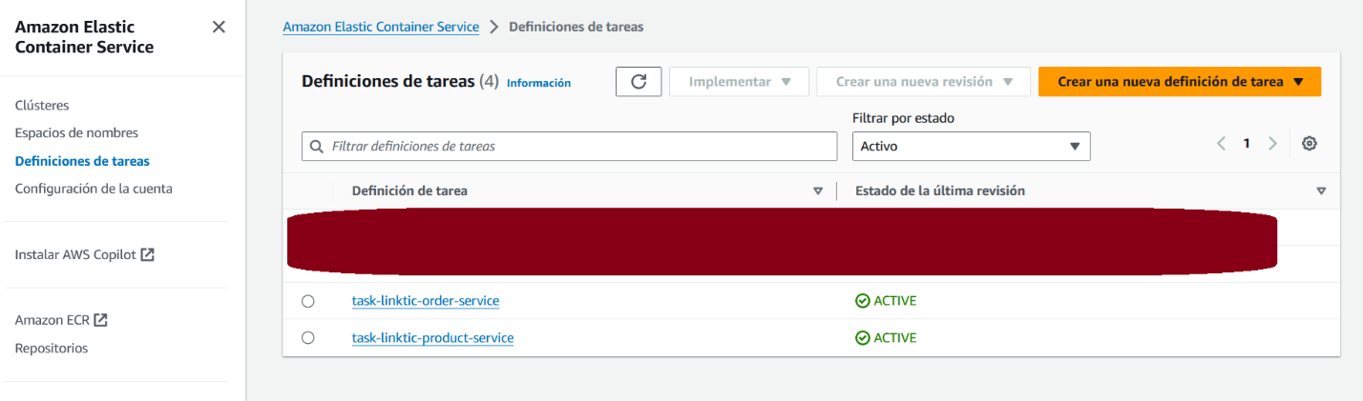

In each task, a service was created which is responsible for deploying and executing the backend developed in Spring Boot.

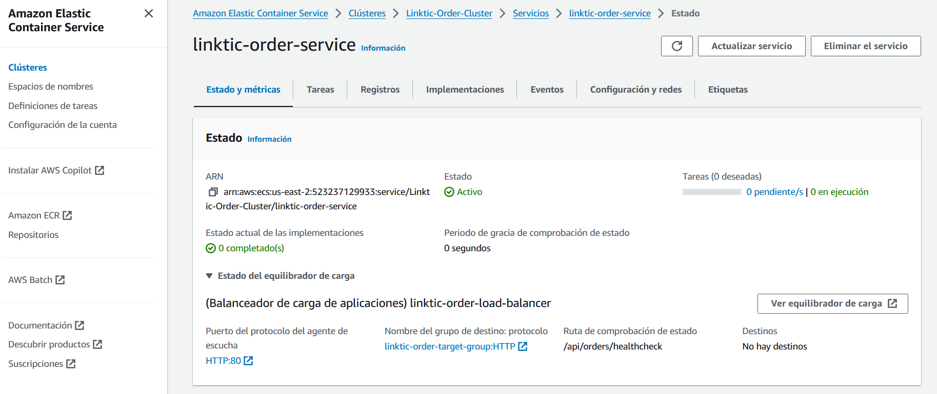

Api Gateway

An API Gateway was created to orchestrate requests to and from the frontend and the two backend services.

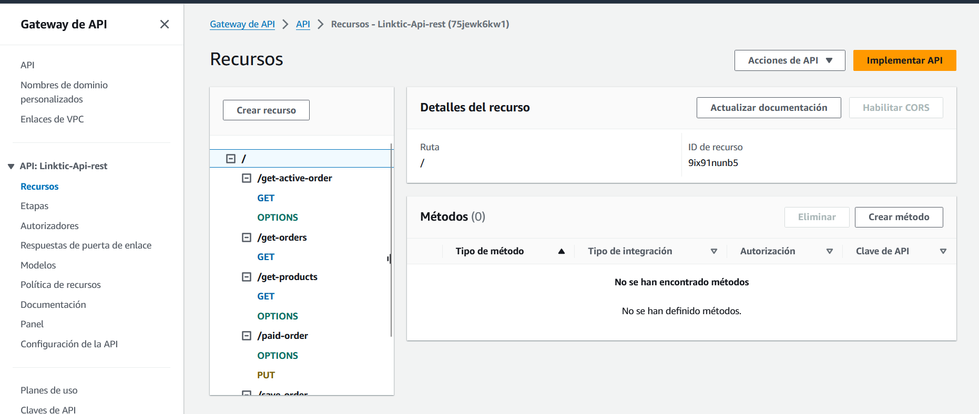

S3

Two buckets were created:

* linktik-ecommerce-front: Contains the built files, `dist` folder, from the Angular project.

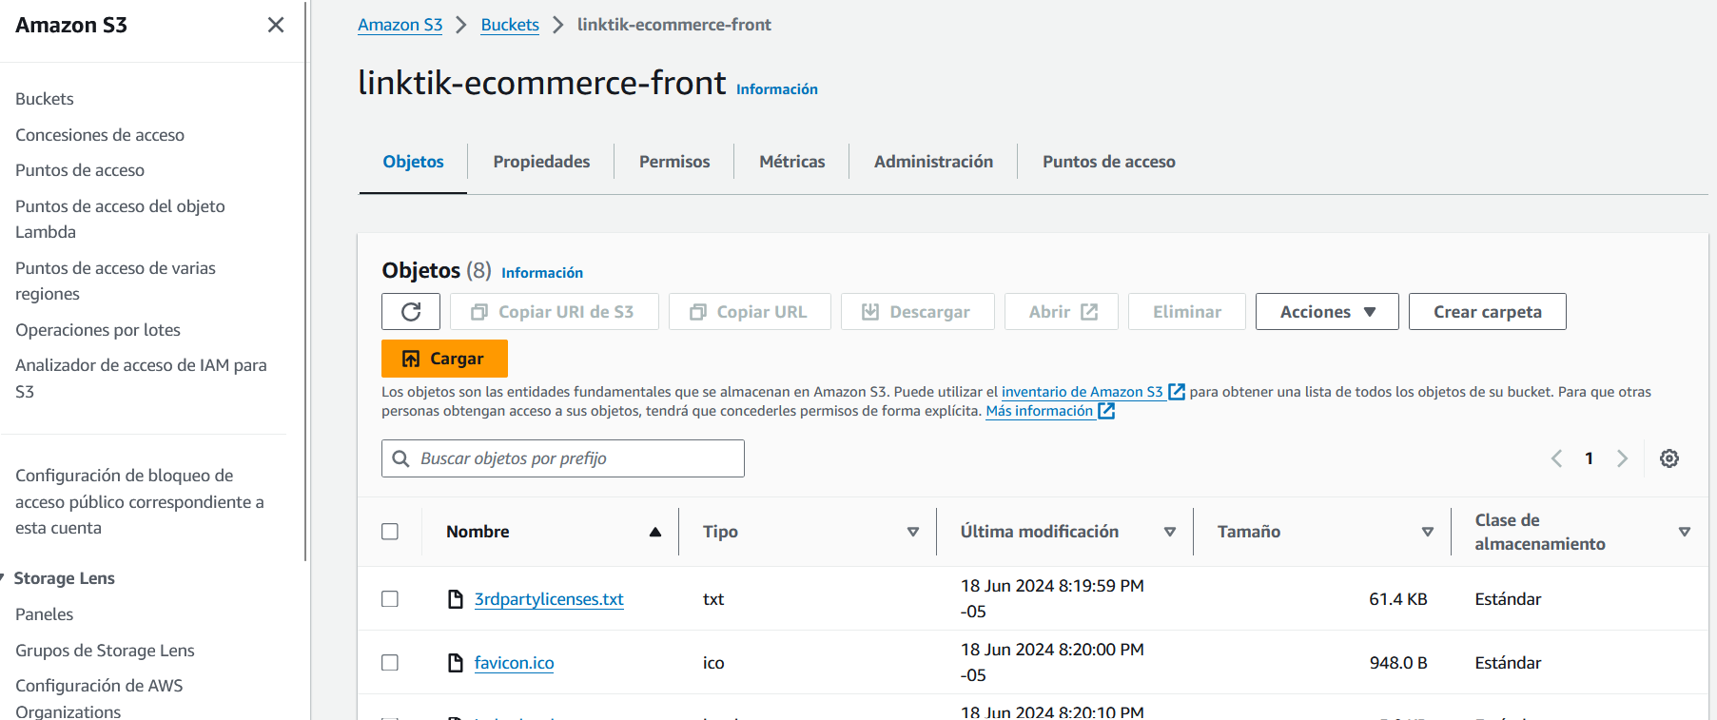

* test-images-ecommerce: Contains the product images to display on the main page.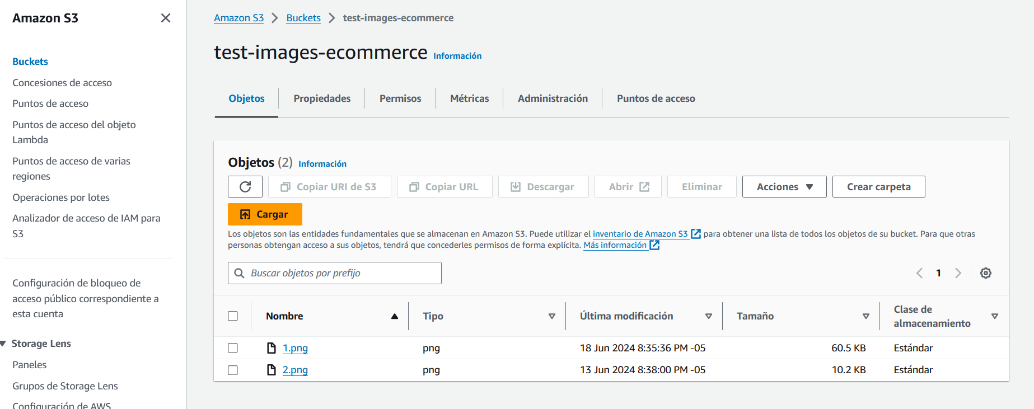

CloudFront

The distribution was created to use the `linktik-ecommerce-front` bucket and deploy the frontend of the web application.

